**Assignment: App Development**

For Learner Use:

|  |  |
| --- | --- |
| Surname of Learner | Dwashu |
| Name of Learner | Nathan |
| Learner ID | 9908305529088 |
| Student Number | ISCTICT20:NDWASHU |
| Date of Test Given | 10/08/2021 |
| Location / Branch | iStudent Academy, Cape Town |

For Assessors Use:

|  |  |
| --- | --- |
| Name of Branch | Cape Town |
| Name of Facilitator | Bradley Van Nelson |
| Name of Assessor | Bradley Van Nelson |
| Assessor Number | RAS/01/2017/0024 |
| Mark Allocation | 58 |
| Mark Obtained |  |
| Competency Status (C / NYC) |  |

|  |  |
| --- | --- |
| Unit Standards MICT Seta | 115392, 115388, 115384, 115431, 115363 |
| Units C&G | 039 |

|  |  |  |  |
| --- | --- | --- | --- |
| Candidates Signature |  | Date of Submission | 20/08/2021 |
| Assessors Signature |  | Date Marked |  |

**Assignment set up:**

This assignment is made up of two tasks:

* **Task A -** Design and create software from a given design specification
* **Task B -** Test and document the software

**Grading criteria**

**Pass –** All criteria shown as [ ] and 34 criteria shown as ( ).

**Merit –** All criteria shown as [ ] and 39 criteria shown as ( ).

**Distinction -** All criteria shown as [ ] and 45 criteria shown as ( ).

**Scenario**

You work as a programmer for Omega Solutions who develop software for clients. You have been asked to design, create and test the software to access an external database. The interface to the database must enable the user to do the following:

* display individual records
* add a new record
* delete a record
* edit a record
* update a record
* cancel amendments for a record
* search records.

A database already exists named Hire containing a table tblCar which contains car details. The table tblCar contains the following fields:

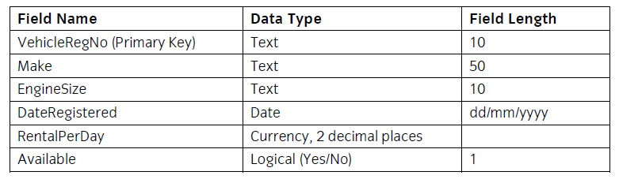

The VehicleRegNo field is a primary key and there cannot be duplicate entries in this field, and a zero-length entry is not allowed.

**Task A –**

In this task you are required to design and create software to access an external database (Hire) with a single table via a database connection and a data form.

Copy the database file(s) that you have been given into the same directory as your project. Make a backup copy of the file(s) in another directory.

Using the Integrated Development Environment:

1. Save the project at regular intervals as you work through the task. Save the form files as frmCars and frmSearch and the Project as CarsDatabase.

2.

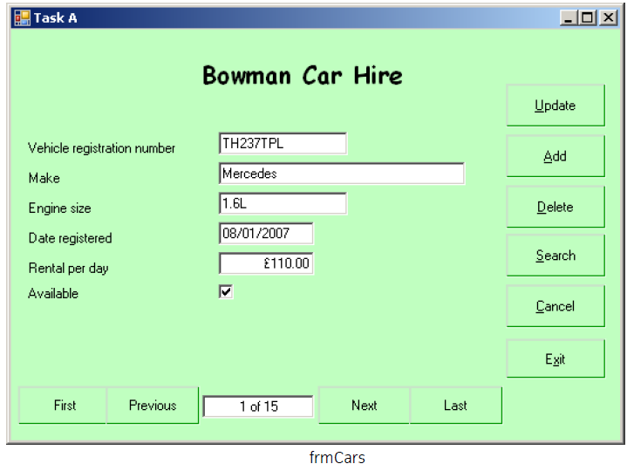

|  |
| --- |
| Create a data form that shows a single record to appear similar to the form shown above and includes:     * a label for the heading 'Bowman Car Hire' in bold with a different font and a larger font size * six controls and associated labels to display the data for the record * controls to move to the first, previous, next and last record * a control to hold a record count in the form n of nn * six buttons for Update, Add, Delete, Search, Cancel and Exit adding the shortcuts as shown * setting the background to a suitable colour * the data input controls receiving focus in an appropriate order. |

3 Set the Text property of the form frmCars to:Task A your name and today's date

4 Make a connection to the database Hire using suitable parameters.

5 Make sure that the formats of the displayed fields are as shown in frmCars.

6 Set up the program so that when the form frmCars is loaded the dataset is loaded automatically and the data for the first record is displayed in the controls.

7 Write code for the Update, Add, Delete and Cancel buttons.

8 Write code for the controls to move to the first, previous, next and last records.

9 Write code in a function to display the total record count and current record number each time one of the navigation buttons Is used. This will be displayed in the control associated with the navigation buttons as shown on the form frmCars.

10 Insert the code required to handle errors for database access which prevents run-time errors.

11 Write code for the Exit button to terminate the program.

12 Add a ToolTip control to the form frmCars.

13 Set the ToolTip property of THREE of the data entry controls on frmCars to an appropriate text value to assist the user when entering data eg for the Make data entry control 'Enter the make of the vehicle'.

14 Write code for the Search button to open a second form named frmSearch.

15 This following form is to be used to allow the user to specify a search criteria and display the matching records from the database table.

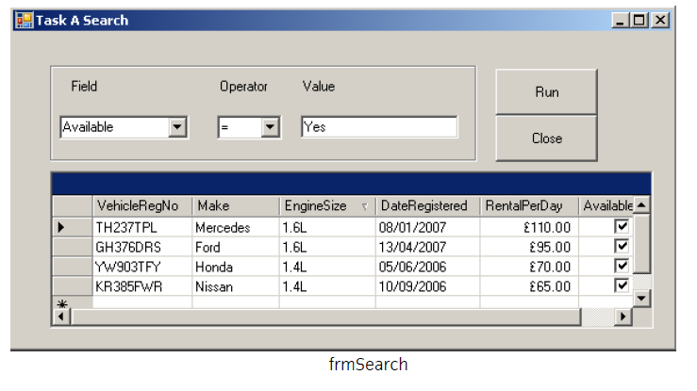

Create a new form frmSearch to appear similar to the form shown above and includes:

* a group box on the form to contain the following:

- two combo boxes named cboField and cboOperator with associated labels

- a text box for data entry with an associated label

* a DataGridView control to display the results of the search
* two buttons named btnRun and btnClose with the text Run and Close
* make sure that the formats of the displayed fields are as shown in frmSearch.

16 Save the form as frmSearch.

17 Set the Text property of form frmSearch to: Task A Search your name and today's date.

18 Write code in the Load function for the form to

* populate cboField with the field names Make, EngineSize, RentalPerDay and Available
* populate cboOperator with the following operator symbols, each one as a single list item: =, <, >, <=, >=

19 Write code for the Run button that will match the search criteria entered using the combo boxes and the value in the data entry text box. The fields VehicleRegNo, Make, EngineSize, DateRegistered, RentalPerDay and Available, for all the records which match the criteria, should be displayed in the data grid. The search should be run only if data exists in all three query criteria controls. A criteria string that is not matched by any record must return nothing.

20 Write code for the Close button to hide the form and return to the form frmCars.

***\**** ***Candidates should produce the following for their Assessor, as attachments to this assignment.***

* ***A printed program listing.***
* ***Screen prints of the forms frmCars and frmSearch.***
* ***The Code will also be assessed***

**Task B** - In this task you are required to test and document the software created.

1 Create test data and expected results to test the Update, Add, Delete, Cancel and Search buttons on the frmCars form and the Run button on the frmSearch form.

|  |
| --- |
| **Test Data** |
| **Add Button Data:**  **Vehicle Registration Number:** KY543HQD **Make:** Audi **Engine Size:** 1.5L  **Date Registered:** 12/08/2009 **Rental Per Day:** R100 **Available:** Yes  **Update Button Data:**  **Vehicle Registration Number:** KY543HQD **Make:** Audi **Engine Size: 1.8**L  **Date Registered:** 12/08/**2012** **Rental Per Day:** R**120** **Available:** Yes  **Cancel Button Data:**  **Vehicle Registration Number:** KY543HQD **Make:** Audi **Engine Size:** 1.8L  **Date Registered:** 12/08/2012 **Rental Per Day:** R120 **Available:** Yes  **Delete Button Data:**  **Vehicle Registration Number:** KY543HQD **Make:** Audi **Engine Size:** 1.8L  **Date Registered:** 12/08/2012 **Rental Per Day:** R120 **Available:** Yes  **Run Button Data:**  **Field:** RentalPerDay **Operator:** > **Value:** R60 |
| **Expected Results** |
| **When Add Button is clicked:** The expected result is that the button should add the new data to the table without any problems and errors. All the data should be in its expected formats. There should also be a popup message that indicates if the add was a success.  **When Update Button is clicked:** The expected result is that the button should update the data without any errors. This means that only the data indicated should be updated and not any other data. Here should also be a confirmation message to assure the data was successfully updated.  **When Cancel Button is clicked:** The expected result is that the button should clear all the data from the textboxes and the checkbox should be unchecked. This must happen without errors and with no indication of problems.  **When Delete Button is clicked:** The expected resultis that the button should delete the complete record that is indicated by the data entered. This should not delete just part of the record but it should delete the entire record. This should work without any errors and indication of problems. Here should also be a confirmation message to insure successful deletion.  **When Search Button is clicked:** The expected result is that the button should open the frmSearch form and hide the frmCars form. This should be done without any errors and should successfully execute.  **When Run Button is clicked:** The expected result is that the button should successfully query the records to display only the indicated records. This should be done without any errors and problems. If the query is not supported the table should display no records. |

2 Prepare a test plan and test the software. Compare the actual results to the expected results keeping a log for each test which identifies any discrepancies between actual and expected results and records any amendments to correct errors. Use debugging tools to help locate and remove errors.

|  |
| --- |
| **Actual Results** |
| **When Add Button is clicked:**  The actual results are very similar to the expected results but there are a few bugs.  **Bug 1:** When a record is added it looks at the first column value of the new record and insert it in alphabetical order into the table. This means the new record will not always go to the bottom but in between records.  **Bug 2:** When I try to clicked the add button it generates an error that states that the txtBoxRentalPDay textbox can’t convert the text to decimal because of the currency symbol. **(Fixed by inserting an if statement to remove the “R” (Currency) symbol)**  **Bug 3: (Created by Bug 2 fix)** The if statement will only remove if the rand symbol is present and no other currencies. Because the letter "R" cannot be converted to a decimal.  **When Update Button is clicked:**  The actual results are very similar to the expected results but there’s a single bug.  **Bug 1:** When I try to clicked the update button it generates an error that states that the txtBoxRentalPDay textbox can’t convert the text to decimal because of the currency symbol. **(Fixed by inserting an if statement to remove the “R” (Currency) symbol)**  **Bug 2: (Created by Bug 2 fix)** The if statement will only remove if the rand symbol is present and no other currencies. Because the letter "R" cannot be converted to a decimal.  **Bug 3:** When you are finished making changes to the record and click the update button it generates an error because the program is having trouble converting the input date format to the table format. **(Fixed by creating 4 string variables and assigning different parts of the date to different strings. Then reversed the order the date was typed in the textbox namely -dd/MM/yyyy to yyyy/MM/dd-)**  **When Cancel Button is clicked:**  The actual results are exactly the same as the expected results and it has no bugs.  **When Delete Button is clicked:**  The actual results are very similar to the expected results but there is a bug.  **Bug 1:** If last record is deleted and the previous button is clicked the program will break.  **When Search Button is clicked:**  The actual results are exactly the same as the expected results and it has no bugs.    **When Run Button is clicked:**  The actual results are very similar to the expected results with a few bugs. All the bugs but one are fixed.  **Bug 1:** The Availability Field can’t accept Yes and No values, only true and false. **(Fixed By creating an if statement that states that if the value of the Availability** **Field is Yes then it turns into true and if No it turns into false.**  **Bug 2:** If you set the field and operator to values that does not make sense e.g., the “Make” field and the “>” operator with the “Mazda” value will return with results that doesn’t make sense. **(Fixed by creating an if statement that will display an invalid input and clear the table of results.)**  **Bug 3:** When the run button is clicked and the results display some columns displays the results in not the desired format. **(Fixed by using the datagridview class “DefaultCellStyle” to correct all undesired formats)**  **Bug 4:** The “<=” and “>=” operators does not work as intended. |
| **Expected Results** |
| **When Add Button is clicked:** The expected result is that the button should add the new data to the table without any problems and errors. All the data should be in its expected formats. There should also be a popup message that indicates if the add was a success. The record should add to the bottom.  **When Update Button is clicked:** The expected result is that the button should update the data without any errors. This means that only the data indicated should be updated and not any other data. Here should also be a confirmation message to assure the data was successfully updated.  **When Cancel Button is clicked:** The expected result is that the button should clear all the data from the textboxes and the checkbox should be unchecked. This must happen without errors and with no indication of problems.  **When Delete Button is clicked:** The expected resultis that the button should delete the complete record that is indicated by the data entered. This should not delete just part of the record but it should delete the entire record. This should work without any errors and indication of problems. Here should also be a confirmation message to insure successful deletion.  **When Search Button is clicked:** The expected result is that the button should open the frmSearch form and hide the frmCars form. This should be done without any errors and should successfully execute.  **When Run Button is clicked:** The expected result is that the button should successfully query the records to display only the indicated records. This should be done without any errors and problems. If the query is not supported the table should display no records. |

3 Locate the EXE file and run the executable file to demonstrate the software.



4 Produce technical documentation to describe the connection details and the purpose of the software.

This application is connected to an external database with the use of Microsoft SQL Server. The end-user will not do any changes in the sql server itself but the application to make data editing more efficient. The purpose of this application is to make data entries and editing of data in the database table easier for end-users. The User Interface is very easy to understand and can save a great deal of time and money in businesses. This application will also not be needing lots of training for first-time users.

When the application start-up it will automatically connect with the sql server database table. So, the end-users don’t have to connect anything. The User-Interface is very straightforward and every object does what it supposed to do. The update button will do updates for any records that needs changes. The add button will add in new records, the delete button will delete a record that is no longer being used etc.

When the end-users click the search button it will open a new form window that will give them the option to search specific records. In this window they can have a table like view to view the records they have searched. There are many ways to filter the records to get only the records the user requires.

5 Print a program listing and screen prints of the forms frmCars and frmSearch.

6 You should check that the program produced meets the following requirement:

* The program must conform to the design specification.
* The program uses the most appropriate controls and events.
* Meaningful names are used for constants, variables, objects, forms and controls using a consistent naming convention.

***\**** ***Candidates should produce the following for their Assessor, as attachments to this assignment.***

* ***Test data, test plan, expected results, actual results and log of testing.***
* ***Technical documentation.***
* ***The Code will also be assessed***